INSTRUCTIONS FOR LOGGING INTO AND USING THE CREATIVE CAMERA CLUB-SOUTHGATE WEB SITE
Front door (I want to view the entire site, but NOT make any entries)
http://www.creativecameraclub-southgate.org/

Back door (I want to edit my portfolio or post a blog entry, but I CANNOT view the other pages)
http://www.weebly.com/weebly/userHome.php
This is the sign in page once you’ve gone through the initial set up and log in. You click on the edit button and enter your user name and password. (BACK DOOR)
(If you have already done this your computer may remember the password and not require you to key it)

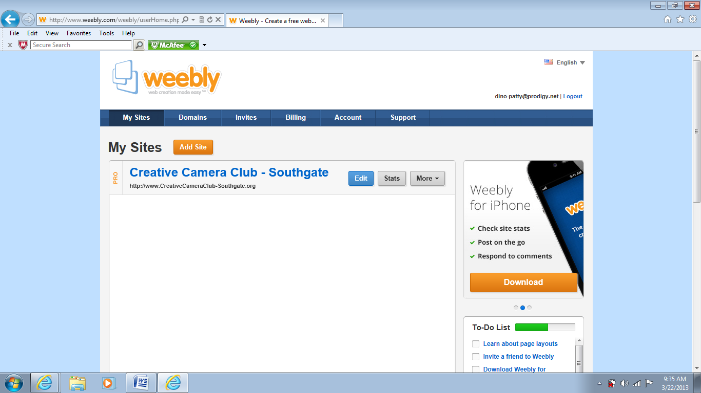

This is a view of the site through the FRONT DOOR
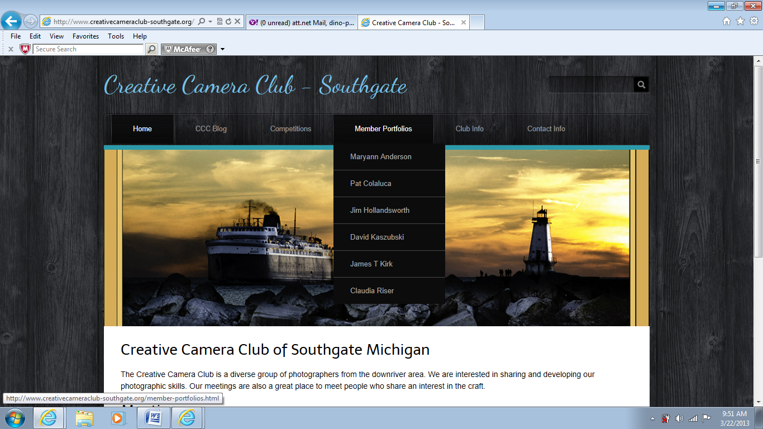

Once you are set up as a “user” you will receive an email from the Weebly site. (Weebly is our Host Site)

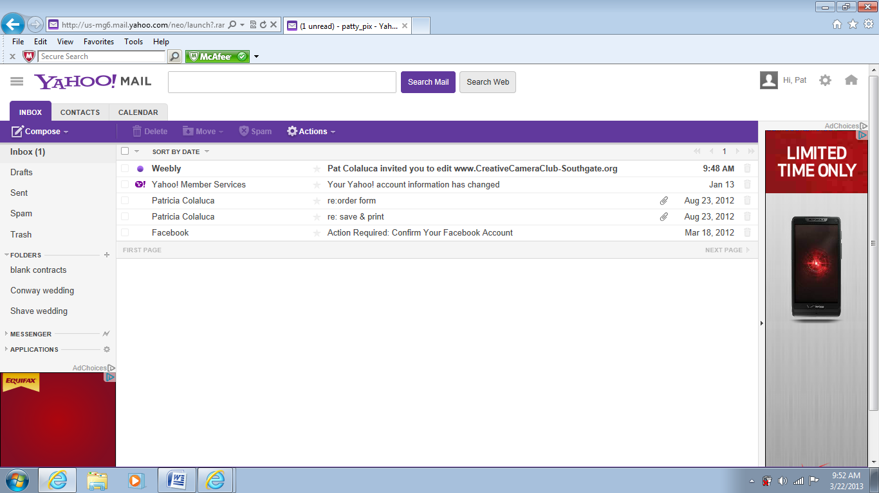

Open the email and click on the link “Click here to get started”.
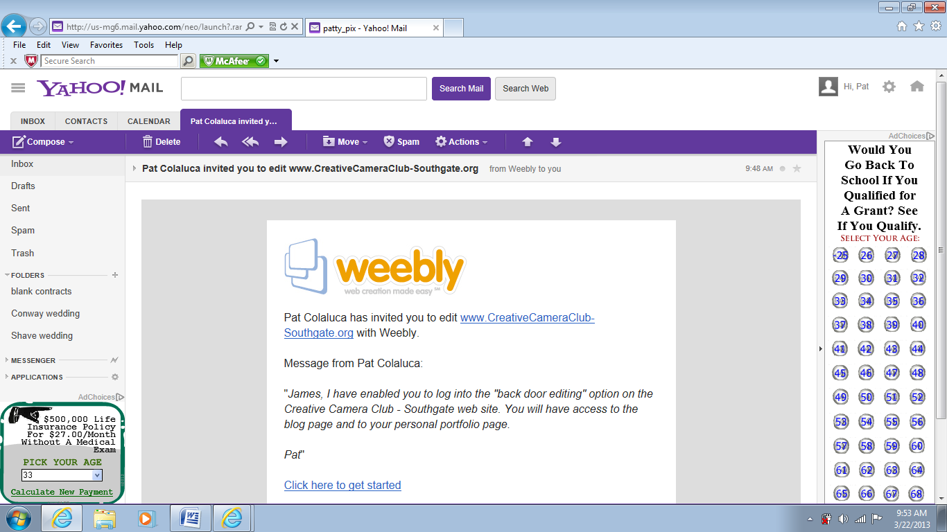

Type in your name, email and password. Type in the Weebly security code and then click on the “Get Started” button.
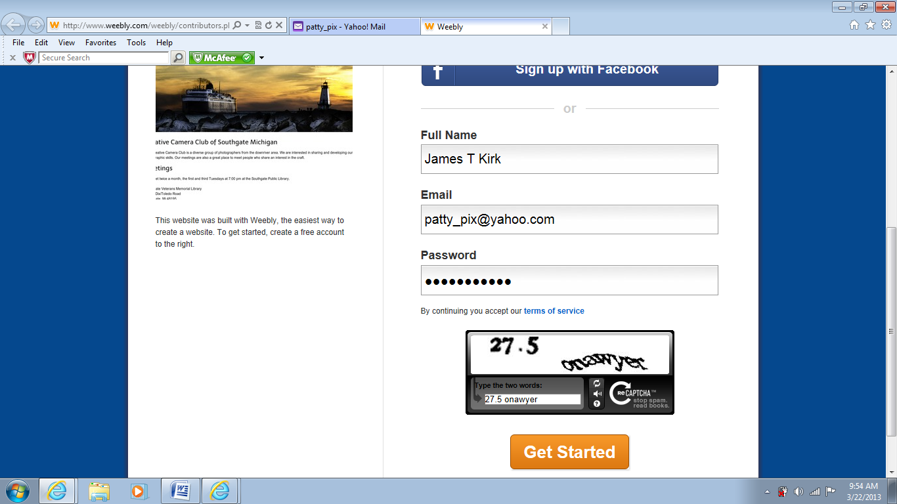

This is what you will get. Notice the blue. They are the only two pages you will have access to. Click on the one you wish to edit.

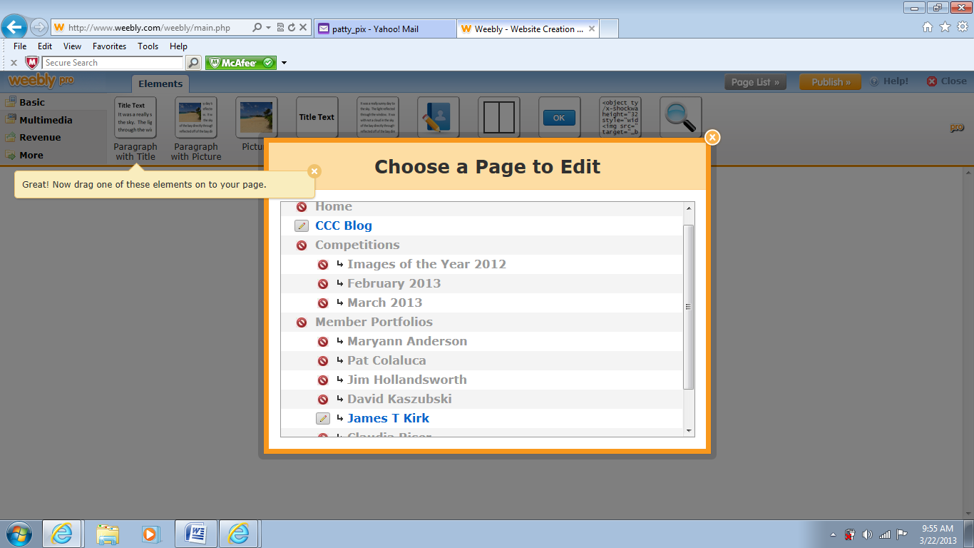
Here I chose the James T Kirk portfolio page. To post images to this page start by selecting: on the top left choose “Multimedia”, then drag and drop the “Photo Gallery” into the area below the title. 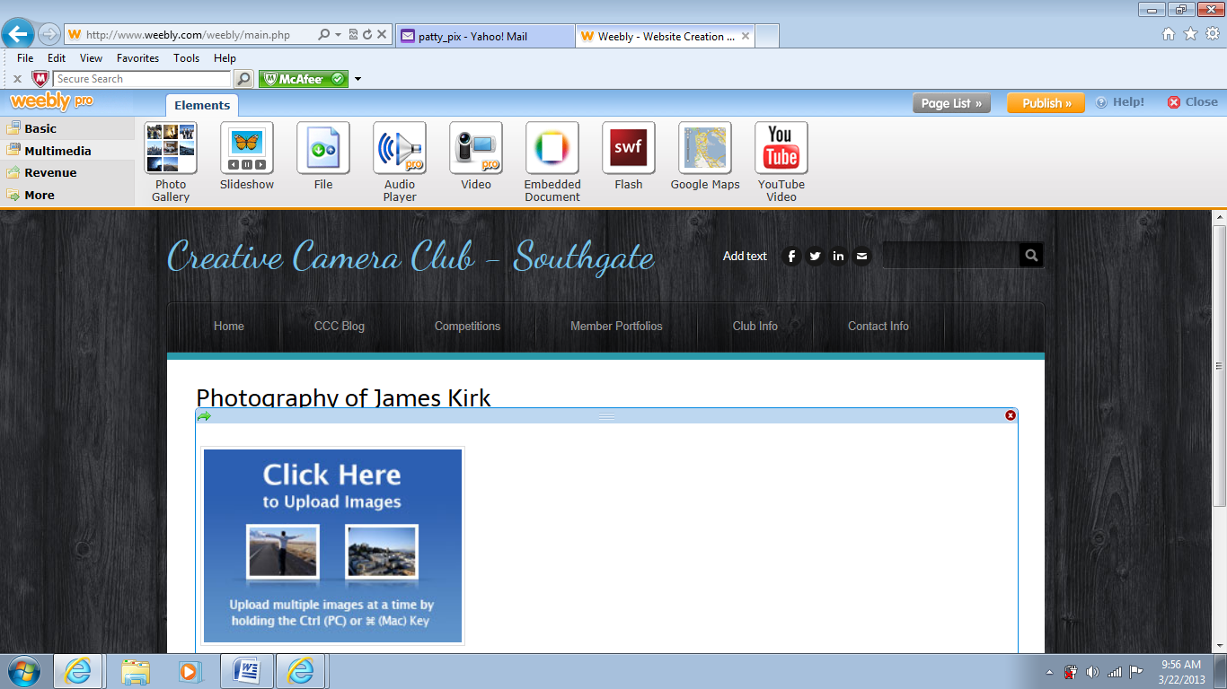

Click on the “Click Here to Upload Images” and an upload button will appear, click on it and then you can go to your computer and pull the photos from wherever you have stored them. Highlight the ones you want and click the Open button, the photos will take a few moments to load.
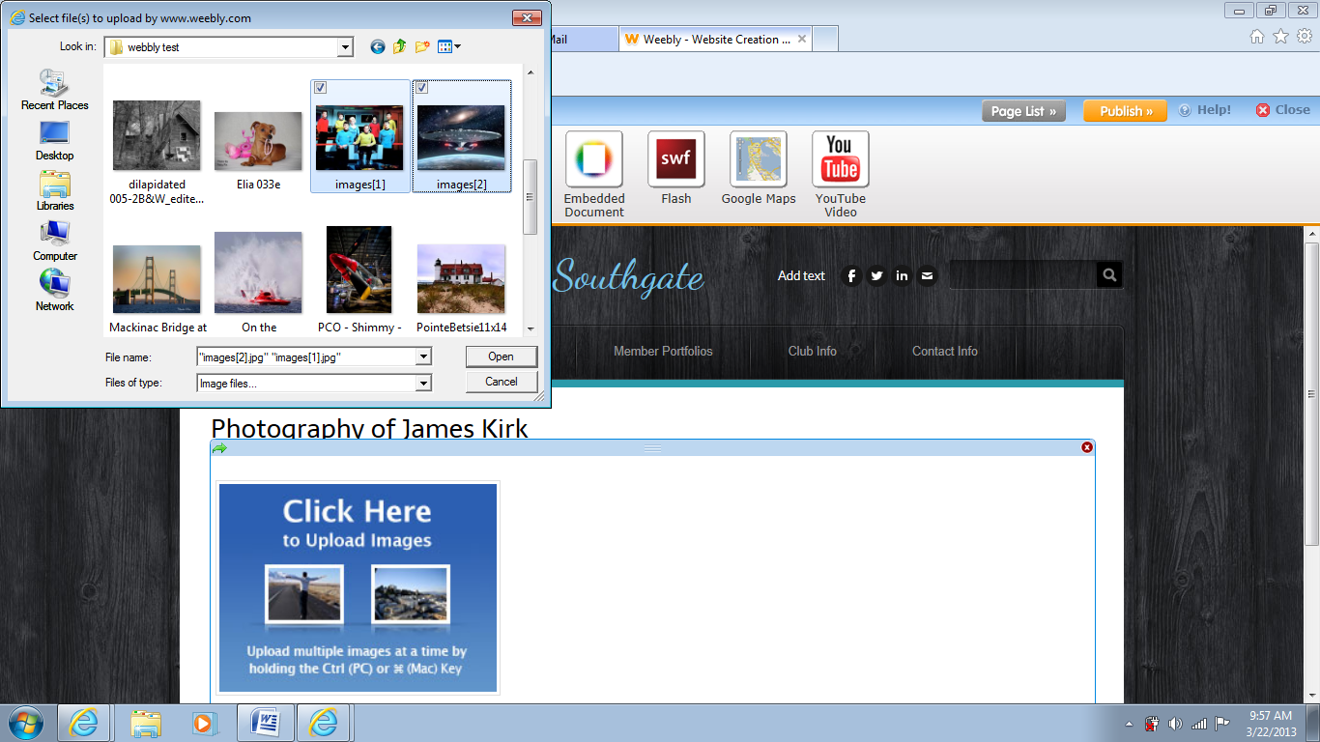
Once the photos are loaded click in the area of the photos and you will see the area outline. Also notice the toolbars that appear. Each photo has a small toolbar and above the photo area is a larger toolbar.
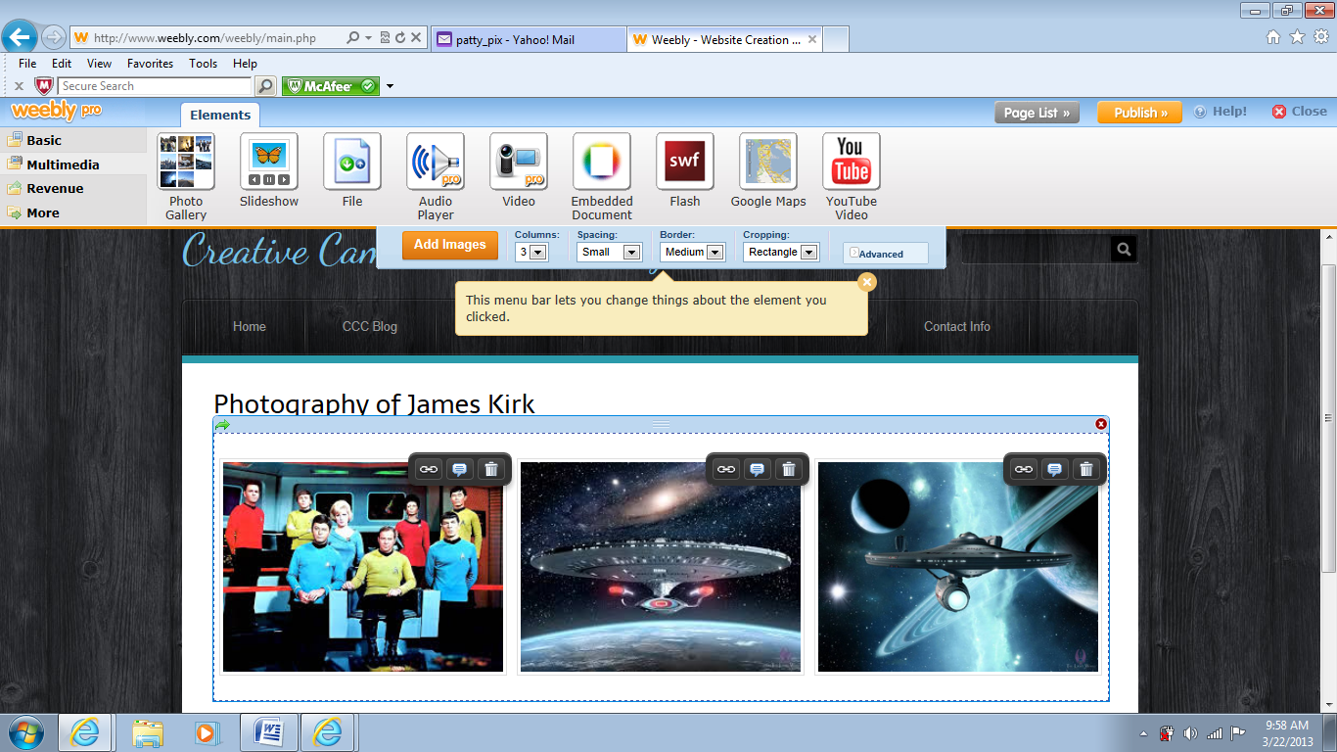

Here are the settings that have been chosen for these photos. (Notice the cropping choice=None)
By choosing None in the cropping drop down you ensure that the site will NOT change the crop of your image.
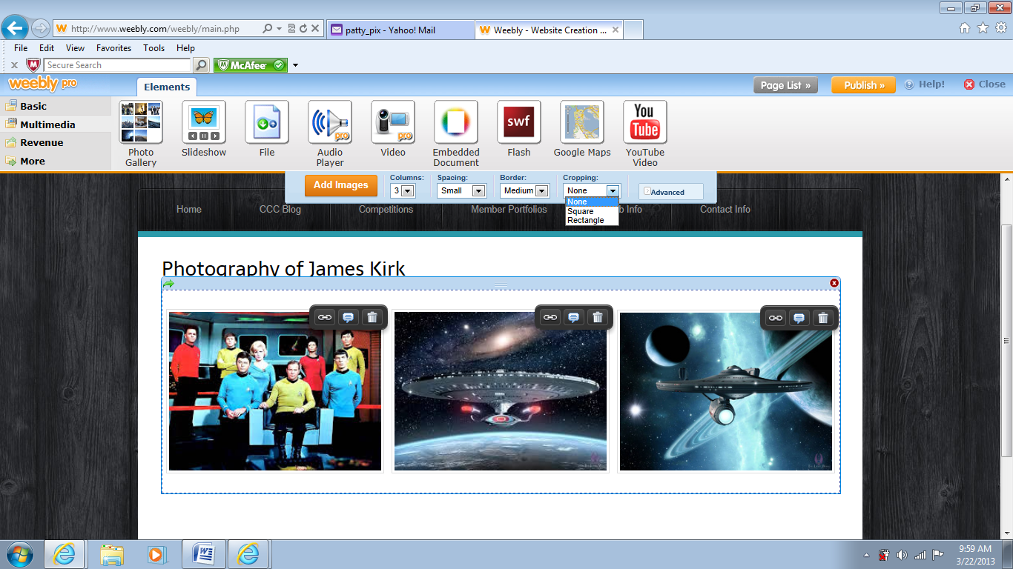Notice the small toolbar above each photo. The center option is a caption box. You can type anything you want here. It will not show up below the image, it will show up when the image is clicked on and shows up at maximum size on screen. To save your changes click on the orange “PUBLISH” button in the upper right corner. If you forget to publish your changes the back door side of the site will see them but the changes will not be visible on the front door side. If that happens, just log back into the back door and hit Publish. (this works, I did this)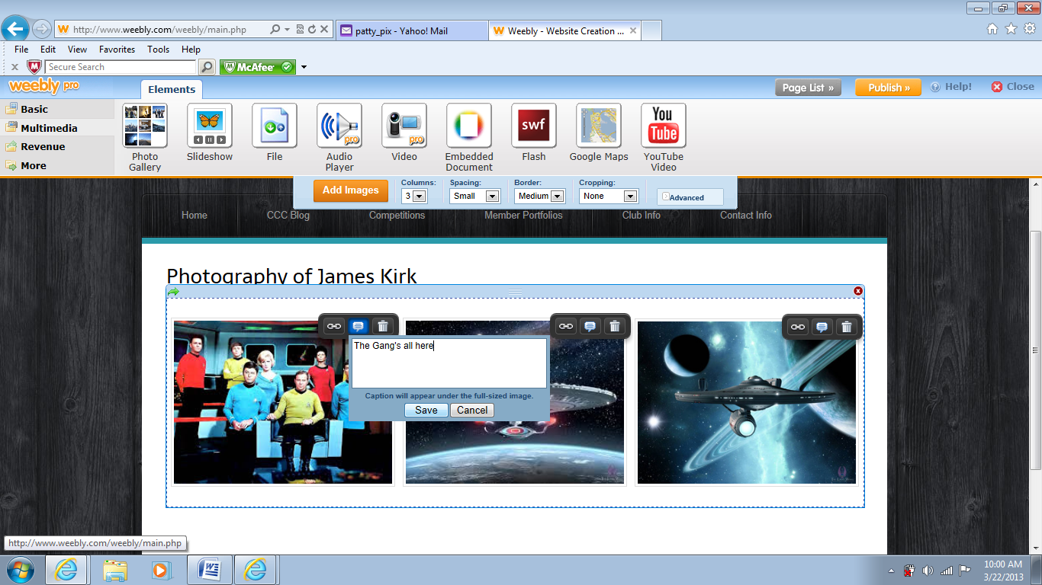

This is the blog page. On the left choose “Basic” option and then below click into the title area and type your title.

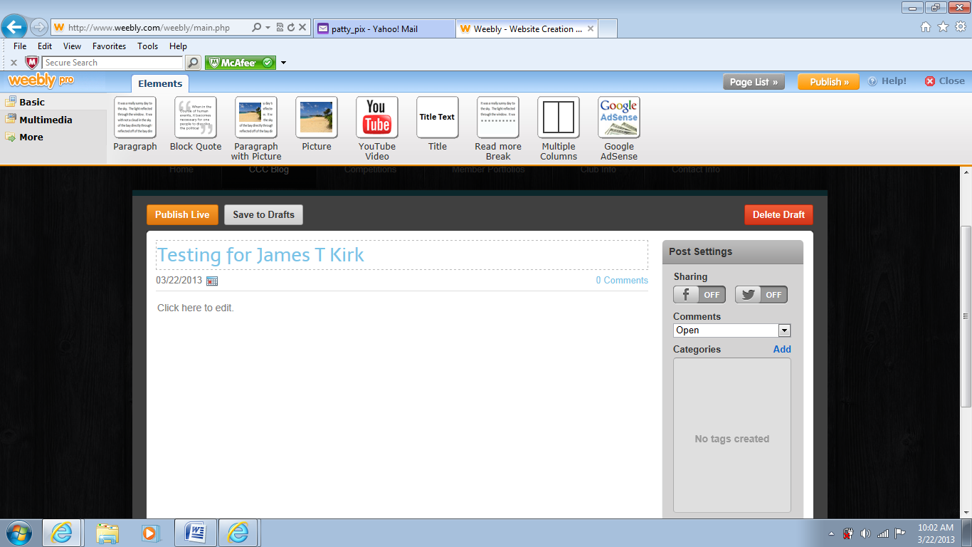
Then go to the toolbar and drag the “Paragraph” down and drop into the blog area. Type away. The entry will not reveal who you are. If you want to post your name in your blog entry you can. Then hit the “Publish Live” button.

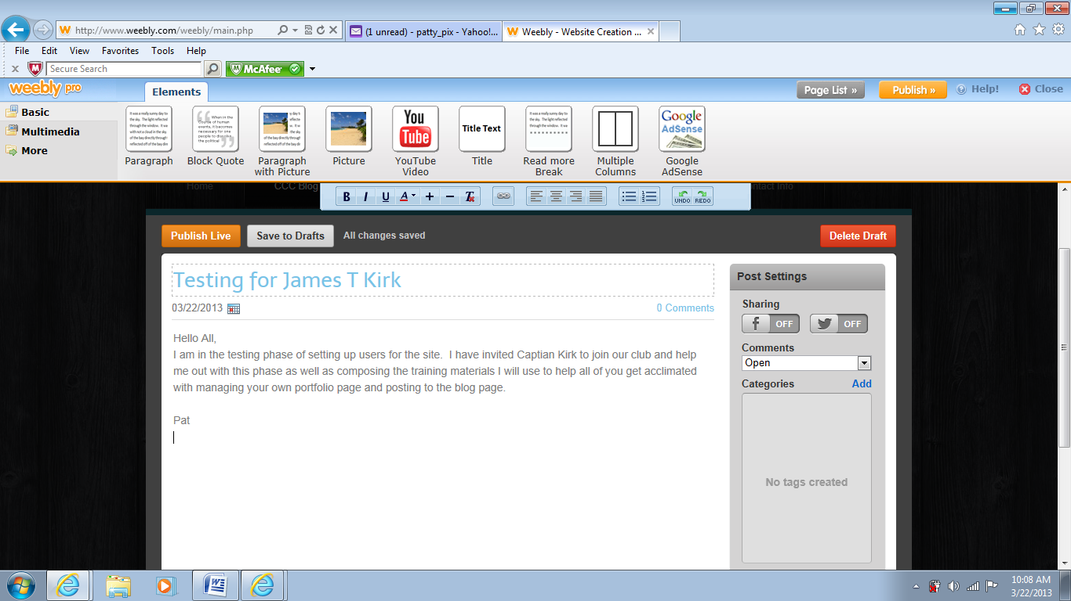
Don’t forget to choose a category for your blog entry. (Categories are the list on the right)
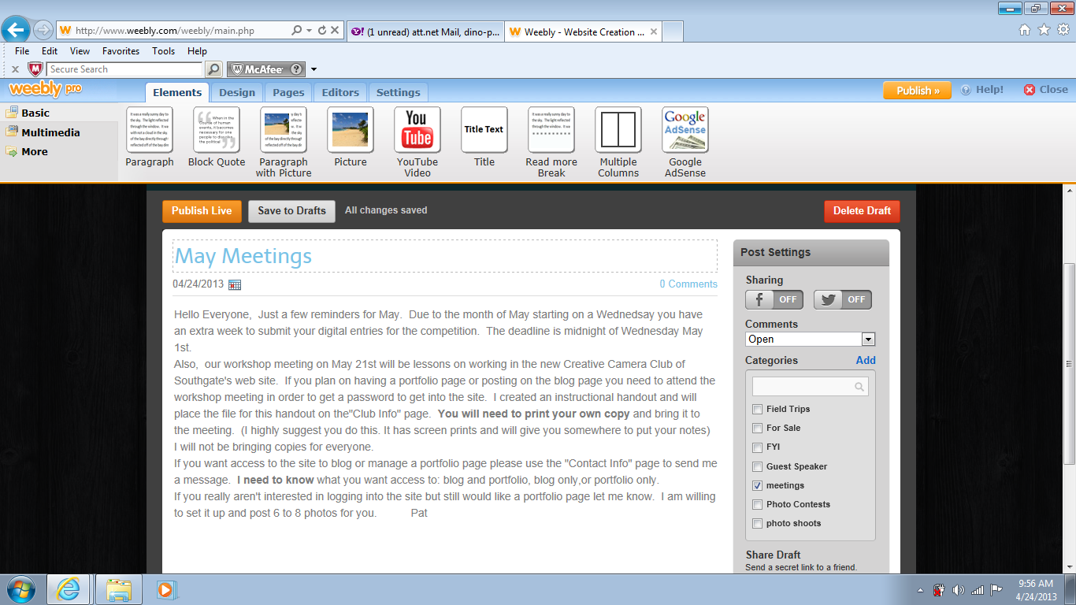
Once you have logged in you will receive this email from Weebly. It has links to Support and Beginners Guide and much more.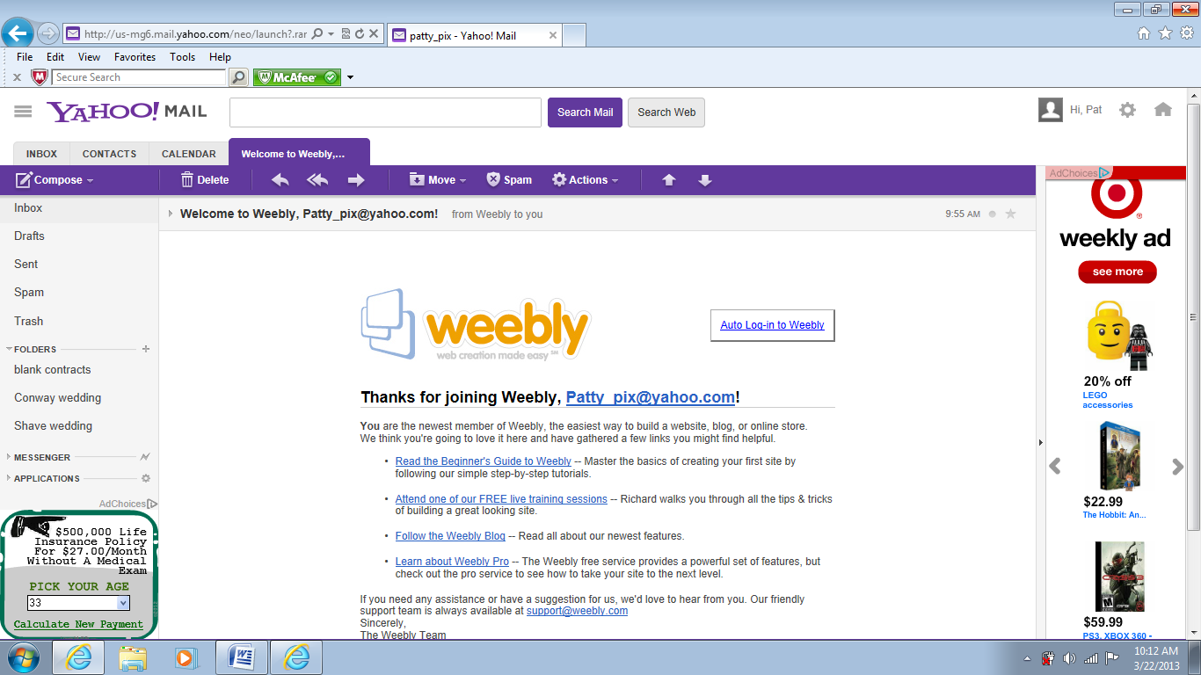
Good Luck!!! Don’t be hesitant. Jump in and have at it. Use the Contact option to send an email and ask questions. Also, feel free to use the support through Weebly if you need immediate assistance.

