Resizing Photos for Digital Competition in Elements

Edit and crop your photo and then go to Image > Resize > Image Size

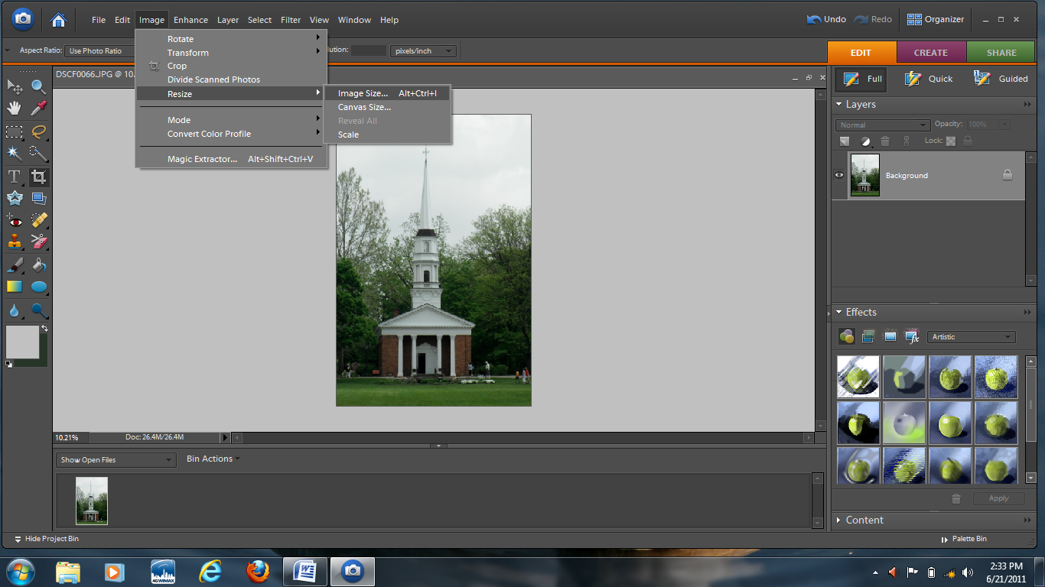

Make sure Constrain Proportions is checked. Resolution maximum is 100. For a vertical crop the maximum Height is 768. Click OK.

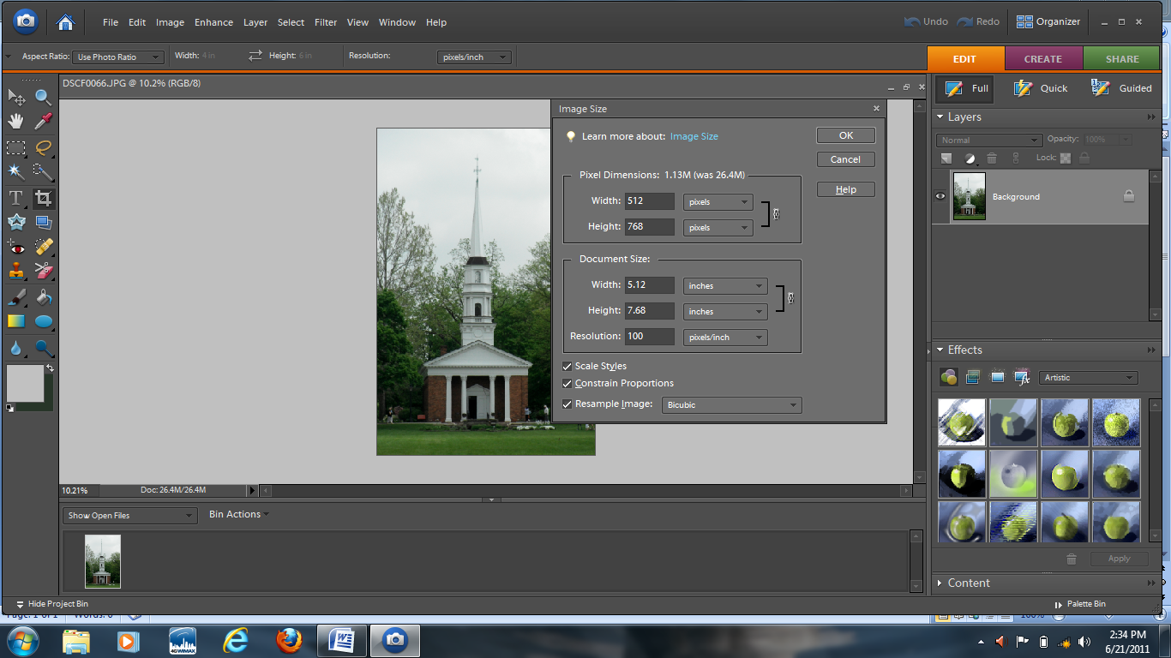
For a horizontal crop the maximum width is 1024.

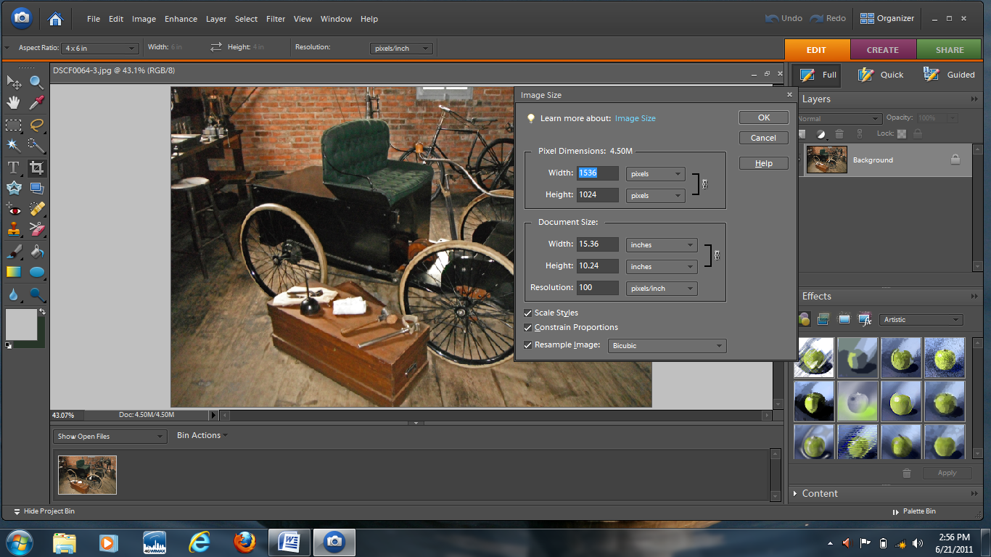

Save under a different name to preserve the original file. File > Save As

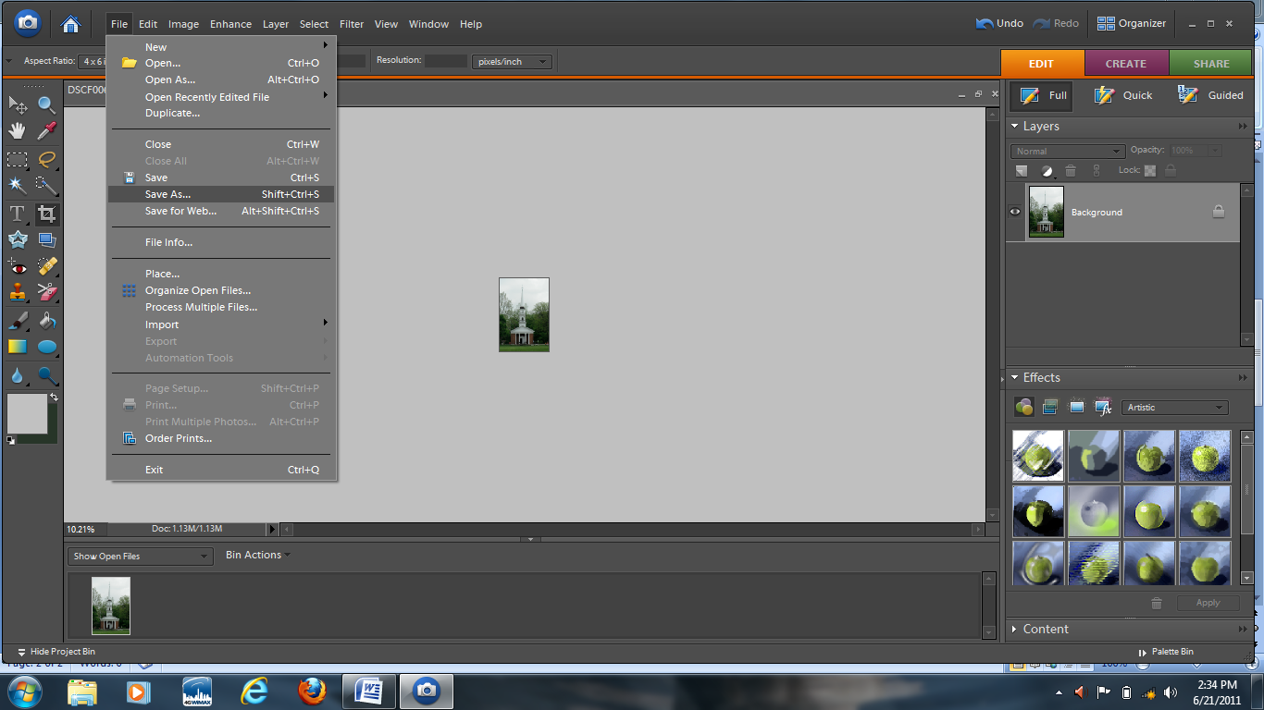

When you save it please name in the format listed in the rules for Digital Competition.
Example: DCO_VillageChapel_pat_colaluca (digital color open_photo name_ photographer’s name)
This is the file that should be sent to Pat and Jim in an email.

